1.INTRODUCTION

1.1 Overview

Unveiling market insights analysing spending behaviour and identifying opportunities for growth. Creating dashboard, story using tableau and analyzsing spending behaviour and identifying opportuties for growth. An ice cream shop that finds data supporting that their clientele are more likely to purchase fruit flavors in the summer months can use those insights to develop strong marketing campaign for their fruit flavors during the next summer season.

1.2 purpose

Distinguish between primary and secondary market research. Define a research goal and the importance of research design. Understand how to cho

ose a sample, and collect analyze data. Identify common sources for secondary market research. Understand how to identify the total available market and serviceable available market.

2.1 EMPATHY MAP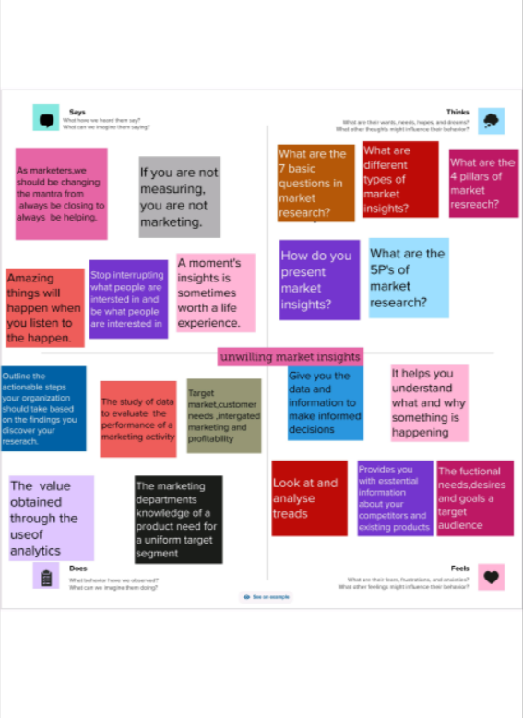

2.2 BRAINSTROMING MAP

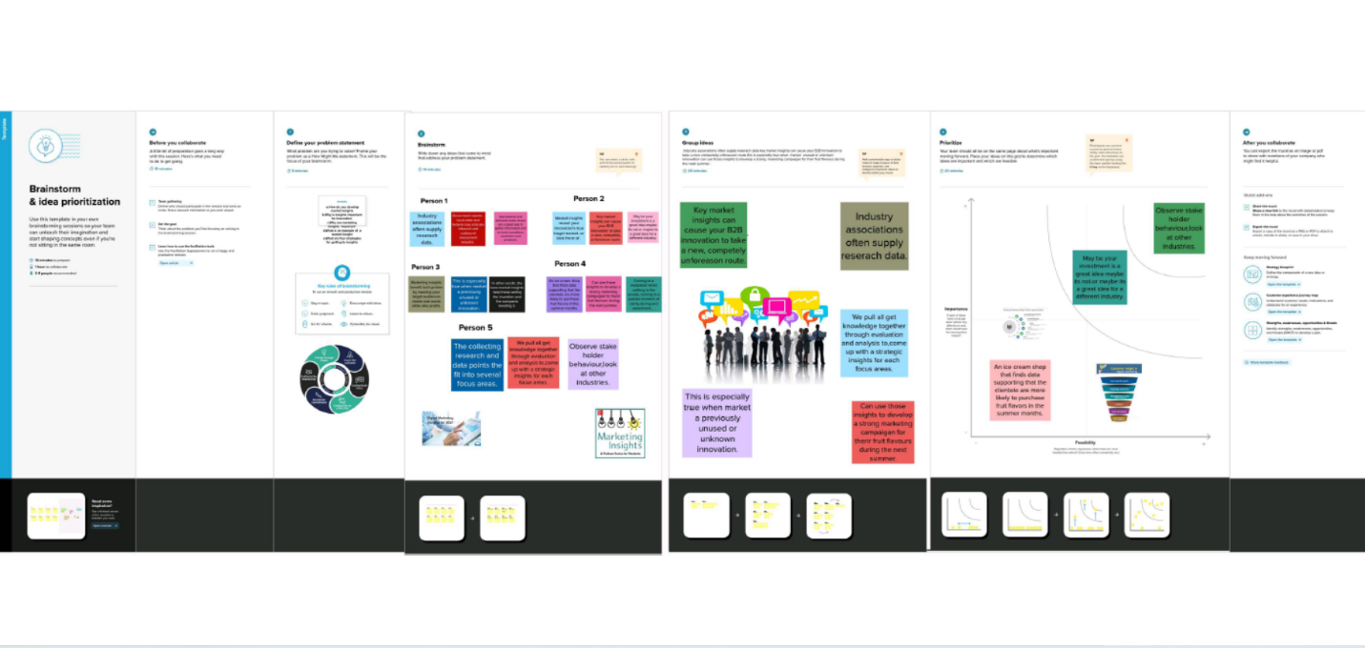

RESULT

Conducting market research is an essential part of any business strategy. By identifying opportunities and customer needs, competition and improve their products and services.

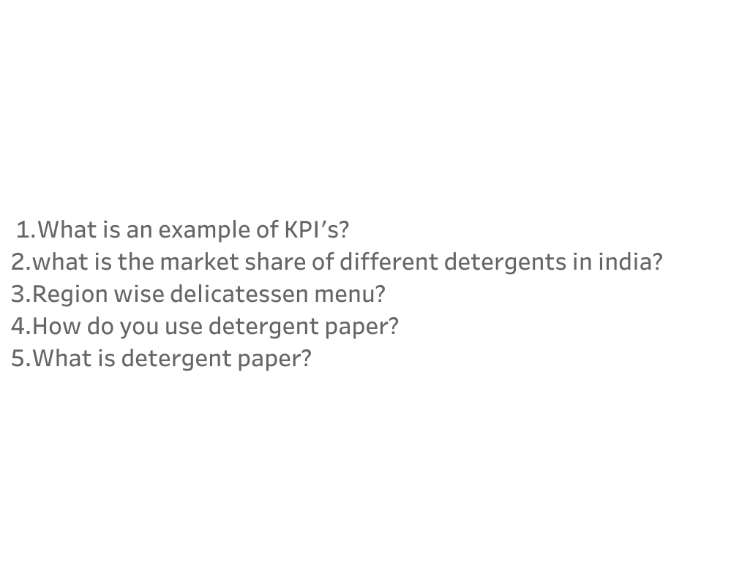

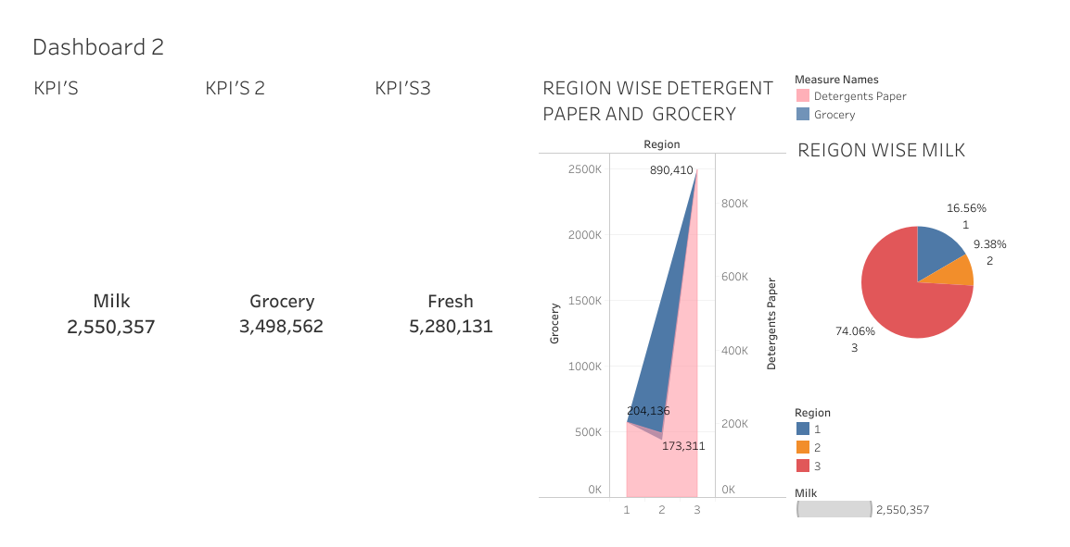

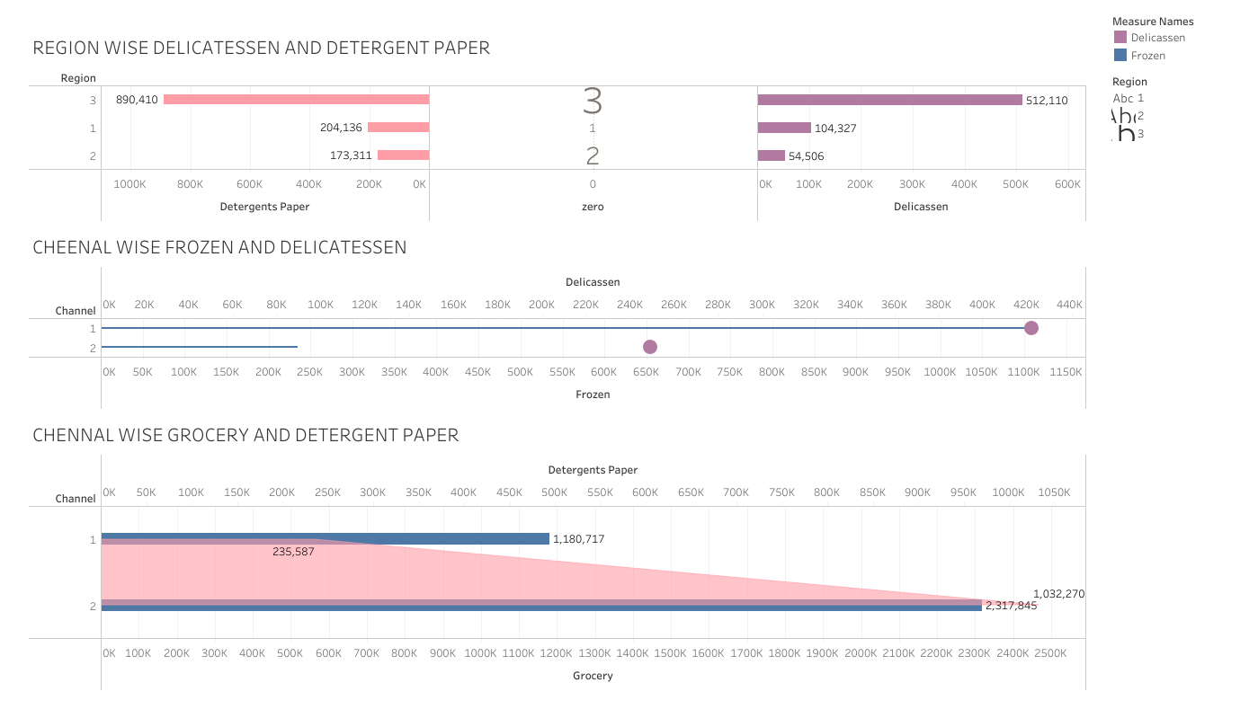

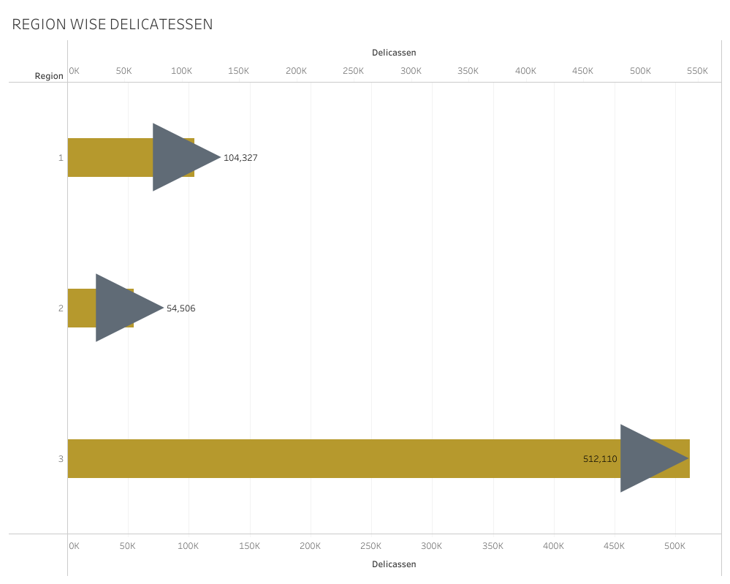

ADVANTAGES

Market research analysis is a powerful tool for businesses to gain a competitive edge in today’s dynamic marketplace. By harnessing the power of data and extracting meaningful insights, companies can make informed decisions, understand consumer needs, and identify growth opportunities.

DISADVANTAGES

Can be expensive implementing a market research strategy can be expensive, especially for businesses. Requires significant time investment, may only target a small population.

APPLICATION

The research delivers market data and CAGR growth rates at global, regional, and key country levels, considering expected short term turbulence in the global economy.

CONCLUSION

It is important to define your objectives, choose the right methodology, collect the right data, analyze the data objectively, and draw meaningful conclusions. With these tips, oun can conduct market research that provides valuable insights into your target audience and helps you achieve your business goals.

FUTURE SCOPE

\*Consumer segmentation

\*Purchase situation analysis

\*Direct computer analysis

\*Foreign market analysis

\*Environmental analysis